Life! program – Eligibility Risk
Criteria a
Recipe Name | Identify patients eligible for theLife! program that meet risk criteria a
Rationale | The following inclusion criteria will determine eligibility for the the Life! program:  - Age 18 years and above  - BMI 25 kg/m² or above (if patient is of Asian background a BMI 23 kg/m² or above)  - AUSDRISK Score 12 or above  The exclusion criteria include patients with:  - Diabetes  - Active Cancer  - Cardiovascular Disease (CVD) diagnosis in the last 3 months
Target | Patients at high risk of Type II Diabetes can be recommended for AUSDRISK or T2DM Diagnostic Testing
CAT Starting Point | - CAT Open – CAT4 view (all reports) loaded.  - Population extract loaded and extract pane "hidden".  - Optional Only: Filter Pane Open and under the 'General' tab, "Active Patients (3x < 2 years)" selected.  *The decision to select either "Active" or "All" patient is left to the practice to make

- In the Filters Pane, under 'General' tab, enter age '18' in the Start Age box under ‘Age’
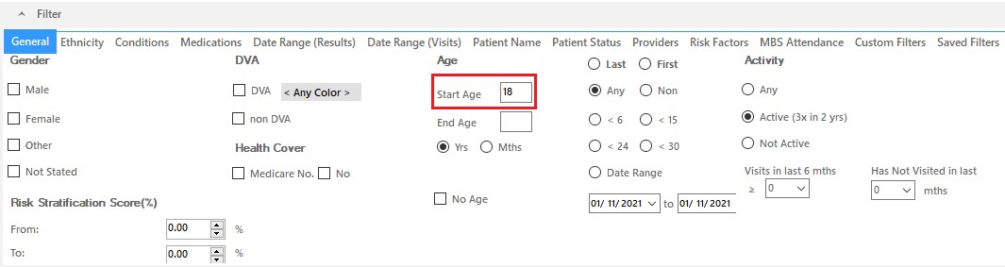

- In the Reports Pane, under ‘Measures’ Report, select ‘BMI’ tab and select ‘Overweight’, ‘Obese’ and ‘Morbid’
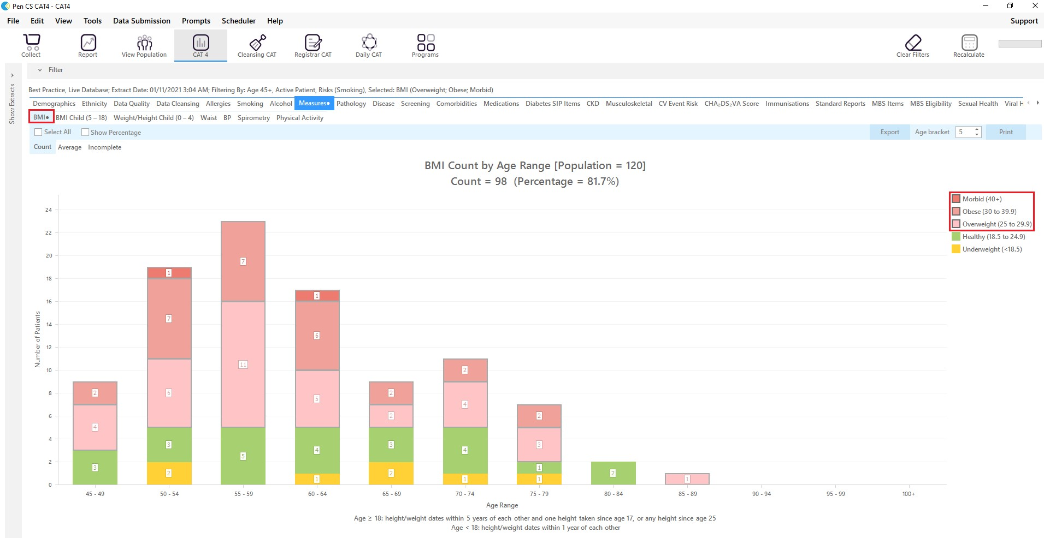

AUSDRISK Score can not be calculated through CAT at this stage but Life! program eligibility A recipe can be followed to narrow down patients
For exclusion Criteria:
- Select Conditions tab then click Chronic tab. Check the box beside the No under Diabetes. This will exclude patients with an existing diagnosis of diabetes.
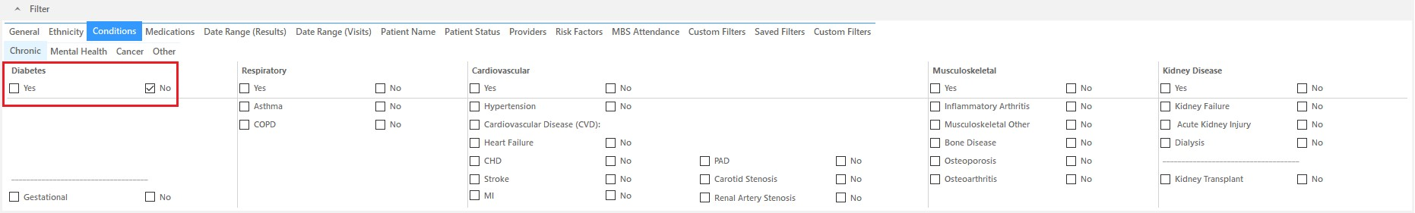

- Click Cancer tab. Check all the No boxes. This will exclude patients with an existing diagnosis of cancer.
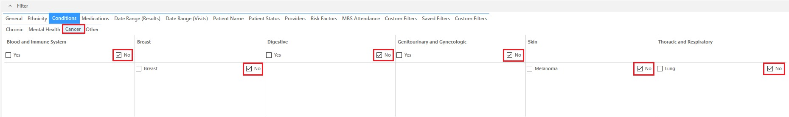

5.

Click Recalculate
button.

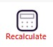
- Click ‘Report’ button to view list of patients meeting these criteria.

- List can be saved/printed or be sent a SMS/Voicemail Recall via the Patient Reidentification window.
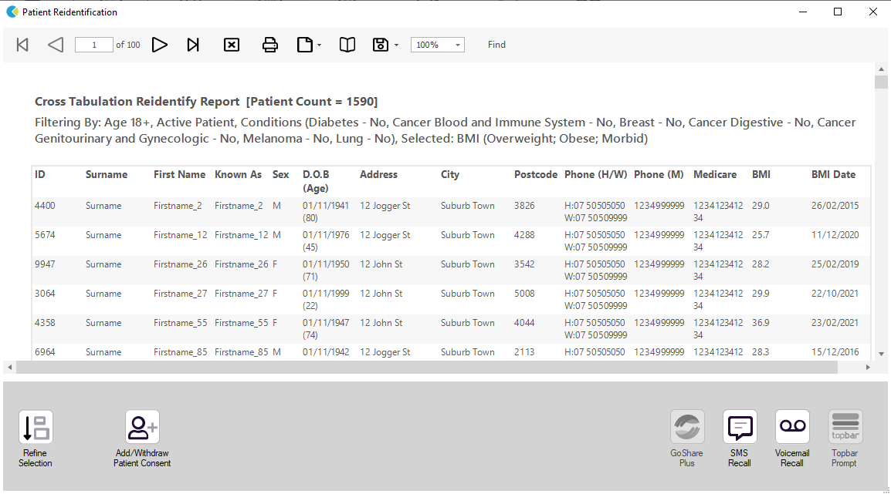

Create a prompt to display in Topbar
Remember you need to be in the CAT4 Daily View to be able to create prompts. Other prerequisites are:
- Topbar is installed
- CAT4 is linked to Topbar via Edit/Preferences/Topbar - check here for details: Linking CAT4 to Topbar
- To start click on the 'Daily View' icon on the top of your CAT4 screen:
- Once you have applied the filter(s) and displayed the patients of interest as described above, you can create a prompt that will be shown to all clinicians using Topbar if a patient meeting the prompt criteria is opened in their clinical system.

